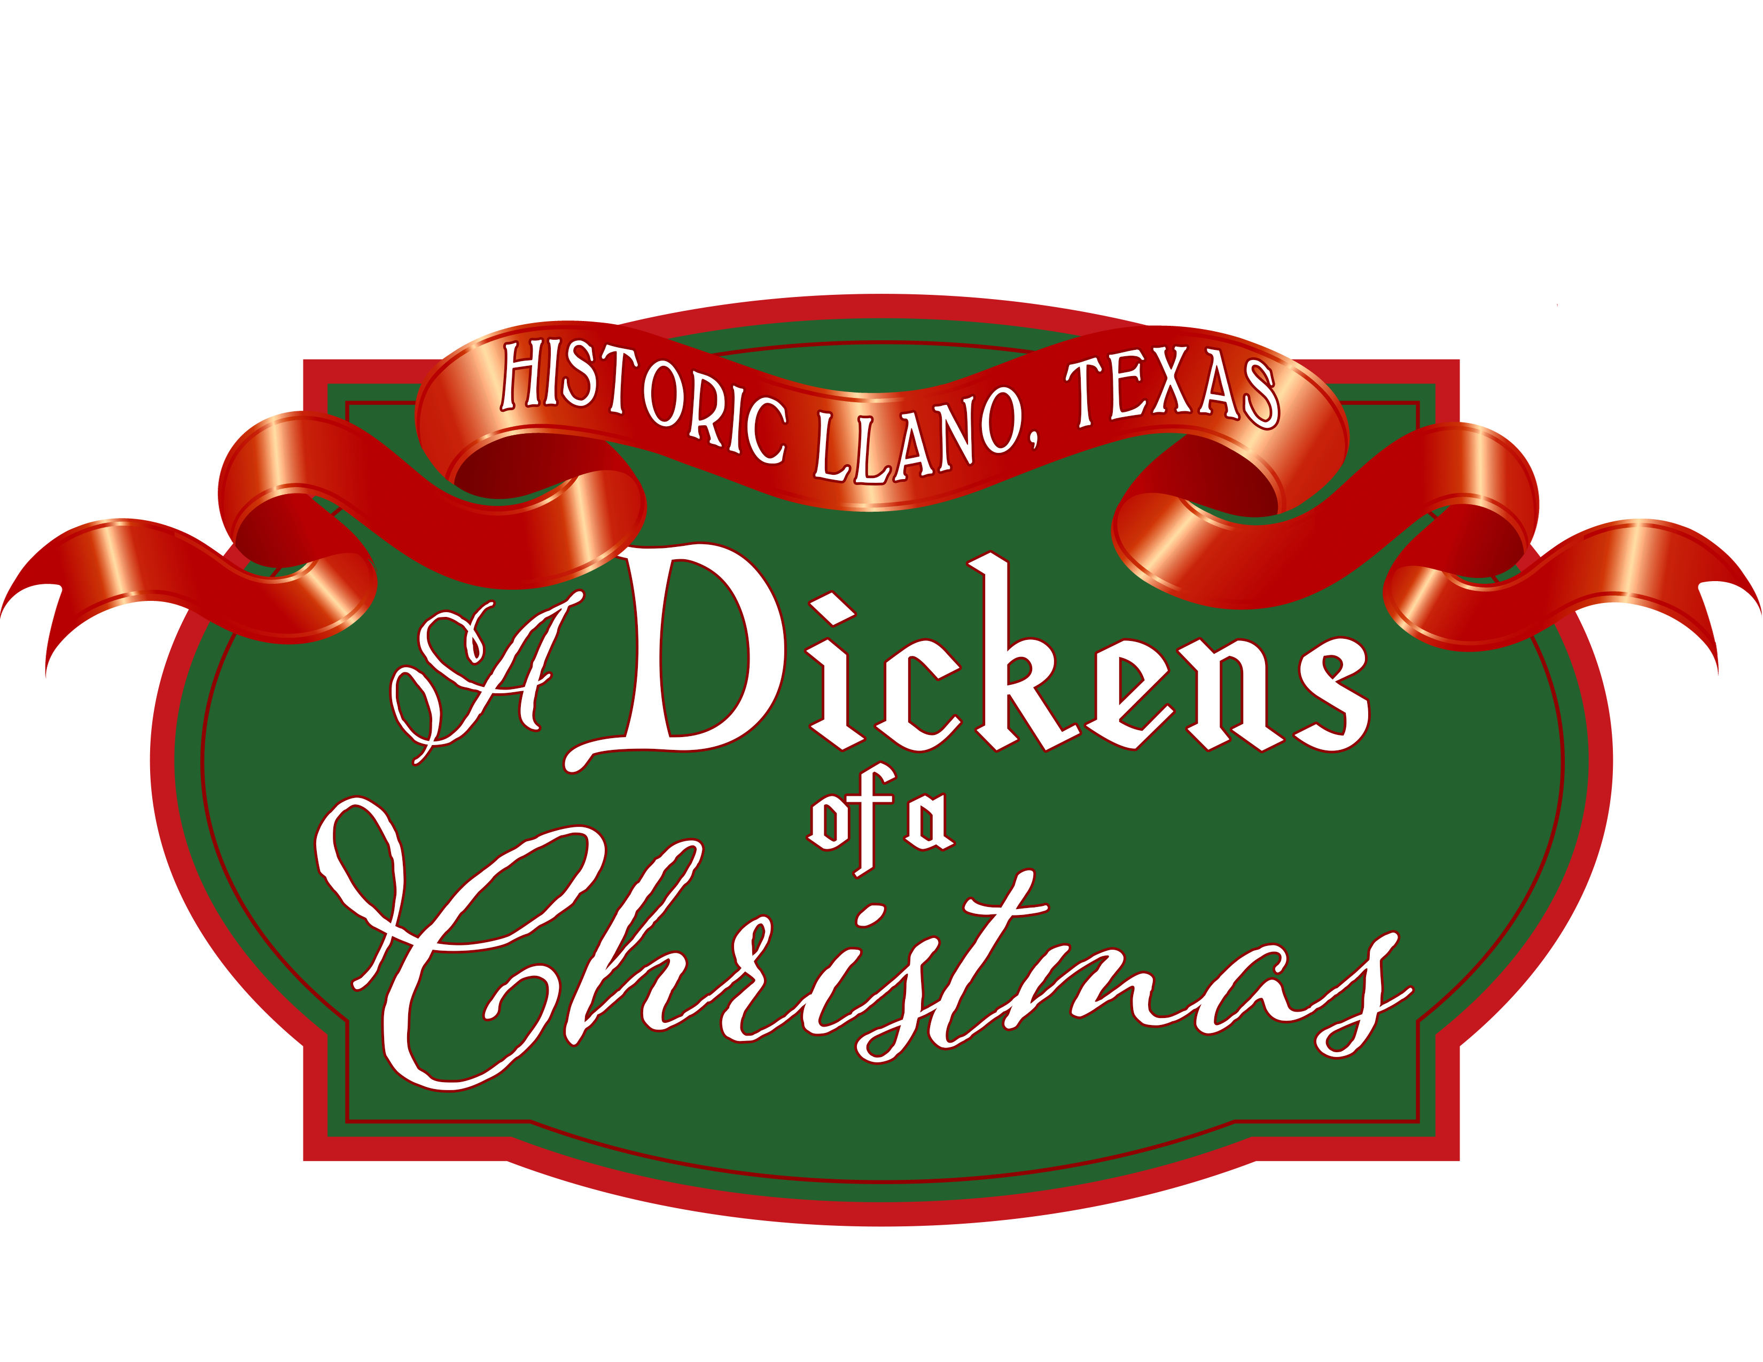A Dickens Of A Christmas in Llano

Bed Race Participation Waiver & Release Of Liability Form

The undersigned hereby acknowledges and assumes all risks associated with and releases The City Of Llano, A Dickens Of A Christmas in Llano" Festival and Volunteers from all liability related to or arising out of the A Dickens Of A Christmas in Llano Bed Race.

In doing so, the undersigned participant is aware the Bed Race safety is dependent, in large part, upon the actions of the undersigned participant. If an accident should occur, the event staff will do everything possible to contact and administer aid services within a reasonable time.

The undersigned participant warrants that they are in good health and are suffering from no debilitating ailment that would affect her or his performance in any manner or jeopardize the health or safety of other persons during the Dickens of a Christmas Bed Race.

Without limiting the foregoing, the undersigned participant warrants that they are not affected by any other health impairment. The undersigned participant is aware that their own health and safety depends on her or his ability to maintain safe conditions, keep a safe distance from other participants, and obey instructions of the event staff. The undersigned participant acknowledges that they may be subject to slips, falling, and normal hazards encountered in this type of event, including without limit, broken bones, fractures, concussions, punctures, lacerations, injuries accidentally inflicted by other participants, and even self­ inflicted injuries, such as blisters, abrasions, cuts, scratches, bruises, injuries sustained in slipping, falling, twisting, spraining, straining of muscles, joints, tendons and ligaments. The foregoing examples are only, listed as examples and are not intended to be all-inclusive. They are meant to establish that the undersigned has knowledge of some of the many risks being assumed.

The undersigned participant assumes the entire risk for any injury, liability or other consequence of involving themselves with the Dickens Of A Christmas in Llano Bed Race. The undersigned hereby waives and releases The City Of Llano, First Baptist Church Llano, and A Dickens Of A in Llano Christmas Festival and its officers, volunteers, and employees, from any and all liability arising out of the event, known and unknown, including without limitation medical expenses, legal fees, loss of services, etc., and shall indemnify and hold all of them harmless from and against any such item.

I have read, understand, and agree to the complete A Dickens Of A Christmas in Llano Bed Race General Waiver and Release Form.

Signature of Adult Participant Date

I am the legal parent I guardian of I have read and understood the complete Llano's A Dickens Of A Christmas Bed Race General Waiver and Release Form and hereby give permission to my child(ren) /ward(s) to participate.

Signature of Parent I Guardian Printed Name of Parent I Guardian Date

